
DEPARTMENT OF AEROSPACE ENGINEERING, SMME, NUST, ISLAMABAD

AIRCRAFT DESIGN LAB
Week#03 Report

Corse Code: AE-424
Course Name: Aircraft Design Lab
Submitted by: Khansa Malik (453832)

Thrust-to-Weight Ratio and Wing Loading Analysis

Introduction
This study estimates thrust-to-weight ratio (T/W) and wing loading (W/S) for a jet transport comparable in size and mission to the Boeing 777-200. These parameters affect takeoff and landing distance, stall speed, climb performance, cruise range, endurance, and turning capability. Each task applies a performance requirement to estimate a design limit or an efficiency target. The results are then converted to takeoff conditions and compared to identify the most restrictive constraint.
The reference design has a takeoff weight of 530,000 lb, cruise Mach 0.84 at 35,000 ft, aspect ratio 8.68, and assumed maximum lift-to-drag ratio of 18. ISA atmospheric properties are used. The calculations are conceptual estimates and depend on the assumptions and empirical relationships selected.

Task 1: Thrust-to-Weight Ratio
Method. Three estimates were compared: Raymer’s statistical correlation for jet transports, cruise matching, and the climb-rate requirement.
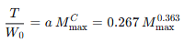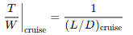
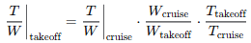
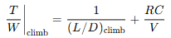
Using M_{max} = 0.84, (L/D)_{max} = 18, (L/D)_{cruise} = 0.866(L/D)_{max}, a weight ratio of 0.956, a thrust-lapse ratio of 0.22, and a climb rate of 1,500 ft/min gave the following results.
Method | Takeoff T/W
Statistical correlation | 0.2506
Cruise matching | 0.2788
Climb requirement | 0.1117
Selected value | 0.279

Output:

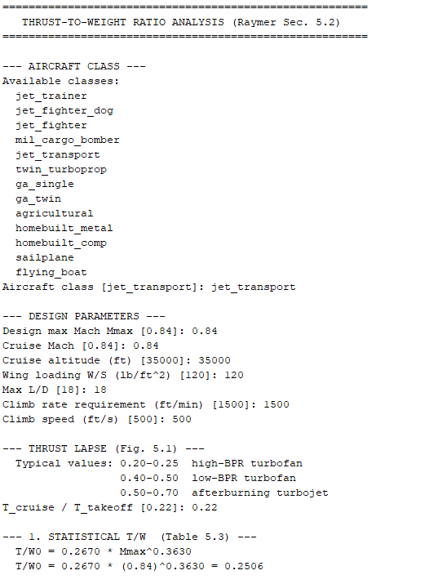
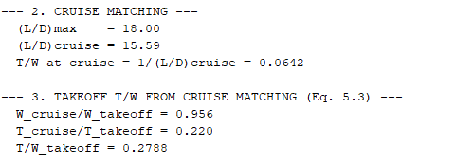
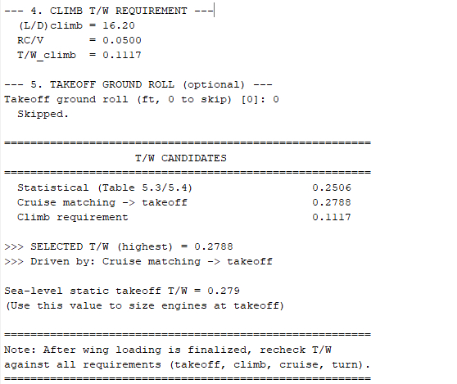

Discussion:
Cruise matching gives the highest estimate and is selected for preliminary engine sizing. The value of 0.279 is close to the cited Boeing 777-200 value of 0.283. The climb-rate estimate is lower, although the separate one-engine-inoperative climb requirement must still be checked.

Task 2: FAR 25 and MIL-C-5011A Field-Length Checks
Takeoff and landing distances were estimated using the selected T/W, wing loading of 120 lb/ft², takeoff CLmax of 2.4, landing CLmax of 2.8, and an 8,000-ft runway. FAR 25 applies certification safety factors; the MIL-C-5011A distances use the stated demonstrated-distance definitions.
Requirement | Estimated distance | Result for 8,000 ft
FAR 25 takeoff | 7,703 ft | Pass; 297 ft margin
FAR 25 landing | 5,302 ft | Pass
MIL-C-5011A takeoff | 6,789 ft | Pass
MIL-C-5011A landing | 4,500 ft | Pass

Output:
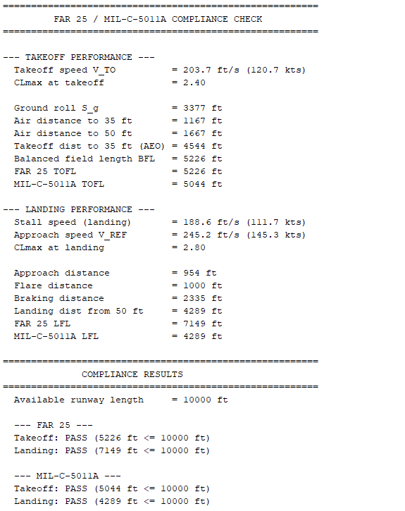
Discussion
All four estimates are below the 8,000-ft runway length. FAR 25 is more restrictive because of its safety factors. The estimated FAR 25 takeoff distance has the smallest margin, so the result is sensitive to the assumptions used for thrust, lift, and field-length estimation.

Task 3: Wing Loading from Stall Speed
At stall, lift equals weight at CLmax, giving the maximum wing loading for the selected stall-speed limit.
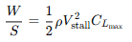
For V_{stall} = 115 kt (194.1 ft/s), sea-level density of 0.0023769 slug/ft³, and C_{L,max} = 2.4, the calculated limit is W/S = 107.5 lb/ft².

Output:
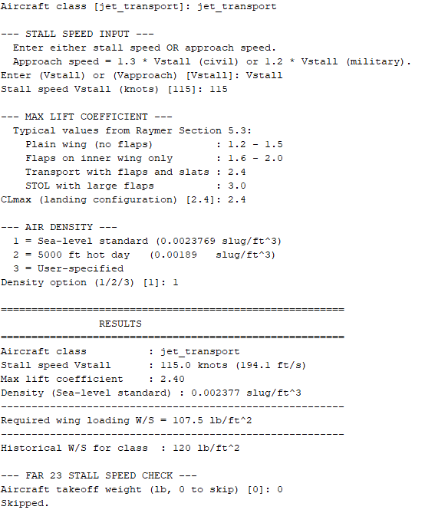

Discussion
The result sets an upper limit on wing loading if the aircraft is to meet the specified stall speed. A higher wing loading would require a higher stall speed or a higher maximum lift coefficient.

Task 4: Wing Loading from Takeoff Distance
Raymer’s takeoff parameter (TOP) relationship for a two-engine FAR 25 balanced field length was used. For the selected linear fit, L = 0.029 TOP − 0.20, with L in thousands of feet.
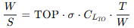
For an 8,500-ft balanced field length, σ = 1.0, C_{L,TO} = 1.98, and T/W = 0.28, TOP = 300 and W/S = 166.3 lb/ft².

Output:
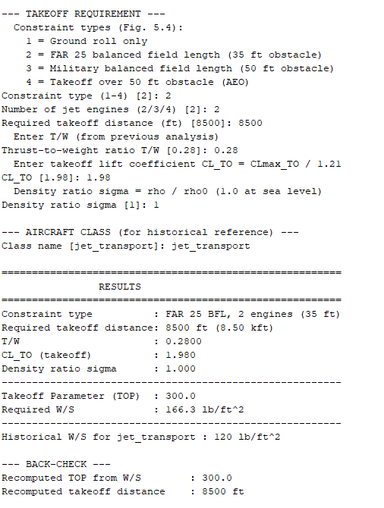

Discussion
The takeoff-distance estimate allows a higher wing loading than the stall, landing, and climb constraints reported in this study. It is therefore not the controlling wing-sizing requirement under these assumptions.

Task 5: Wing Loading from Landing Distance
The 5,000-ft FAR 25 landing-field-length requirement was converted to a demonstrated distance using the 1.67 factor. A 1,000-ft air segment was subtracted, and the thrust-reverser factor of 0.66 was applied to the ground-roll term.
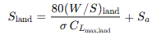
With C_{Lmax},landing = 2.4, σ = 1.0, and W_{landing}/W_{TO} = 0.85, the reported landing-condition limit is 90.6 lb/ft², equivalent to 106.6 lb/ft² at takeoff.

Output:

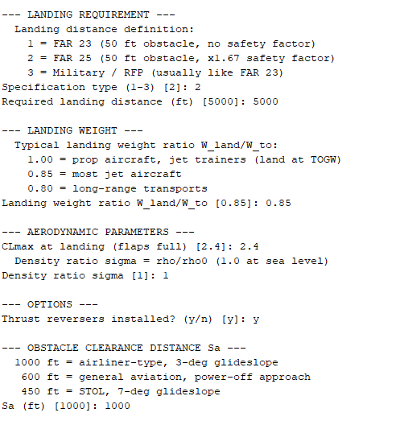
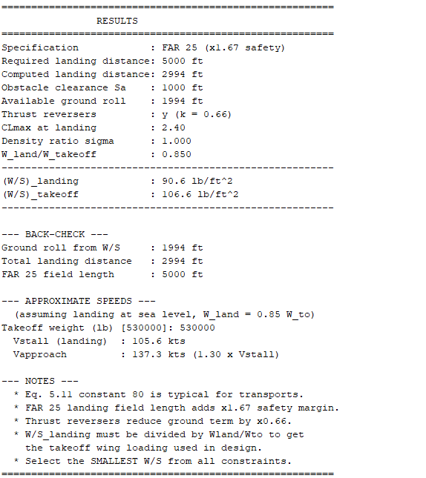

Discussion:
The landing requirement is restrictive because the aircraft must dissipate its speed and stop within the specified distance. The reported takeoff-equivalent limit is 106.6 lb/ft², subject to the landing-distance and thrust-reverser assumptions.

Task 6: Wing Loading for Maximum Cruise Range
For a jet aircraft at the maximum-range condition, parasite drag is taken as three times induced drag.
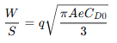
At 35,000 ft and Mach 0.84, the analysis uses ρ = 0.00073725 slug/ft³, V = 817.2 ft/s, q = 246.2 lb/ft², AR = 8.68, e = 0.80, and C_{D0} = 0.015. The reported optimum is W/S = 190.8 lb/ft².

Output:
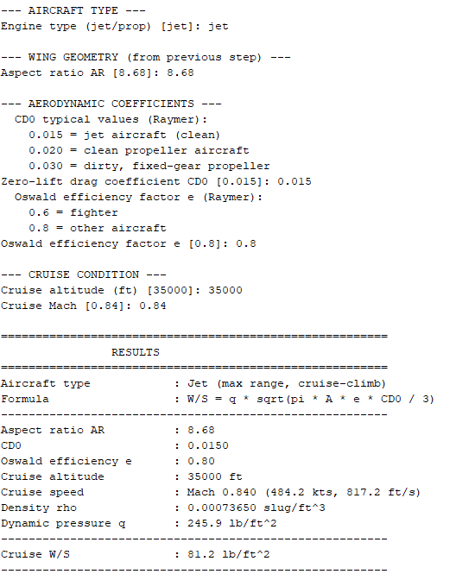
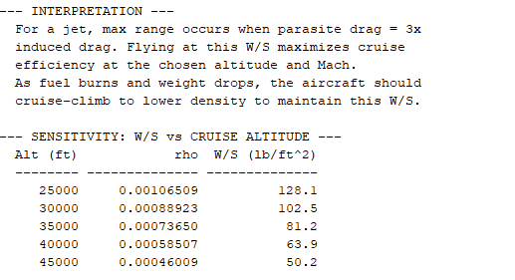

Discussion:
This value is an efficiency target rather than a hard structural or operational limit. Actual cruise wing loading changes as fuel is consumed, and the optimum depends on the assumed drag polar and flight condition.

Task 7: Wing Loading for Loiter Endurance
Maximum jet endurance is associated with the maximum lift-to-drag condition, where parasite and induced drag are equal.
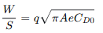
The stated conditions are 30,000 ft, 180 kt, AR = 8.68, e = 0.80, C_{D0} = 0.015, and W_{loiter}/W_{TO} = 0.85. The source report gives a code output of 135.7 lb/ft² at loiter and approximately 159.6–159.7 lb/ft² at takeoff.

Output:
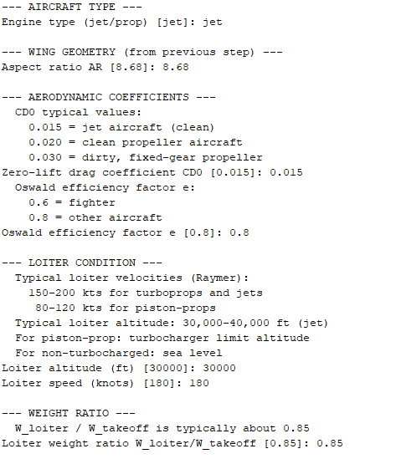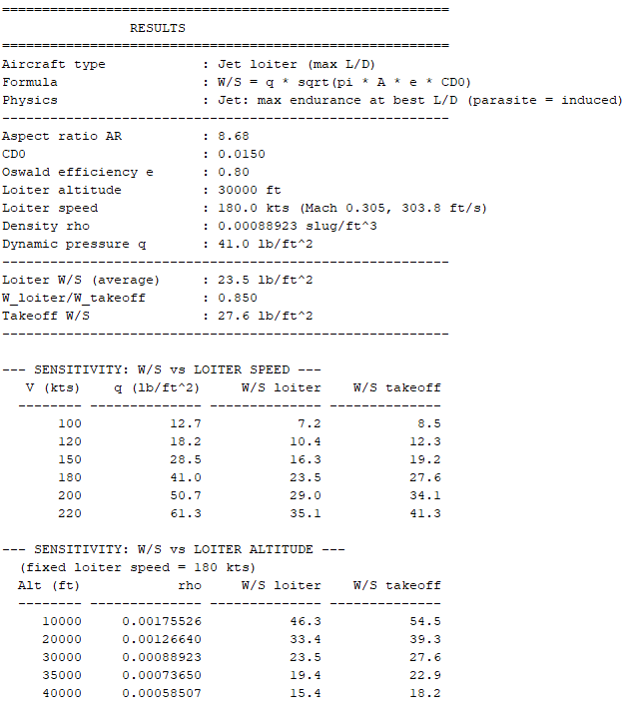

Discussion:
The original calculations contain an unresolved discrepancy: substituting the listed density and speed into the stated equation gives a value far below the reported code output. The reported output is retained here, but this task should be recalculated from the MATLAB script before the result is used for design decisions.

Task 8: Wing Loading from Instantaneous Turn
The required load factor is calculated from the turn rate and speed, then used to estimate the maximum wing loading.
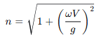
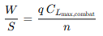
For 18°/s at 350 kt and 15,000 ft, the report calculates n = 5.85 and combat wing loading of 44.6 lb/ft². With W_{combat}/W_{TO} = 0.85, the takeoff-equivalent value is approximately 52.4–52.5 lb/ft².

Output:
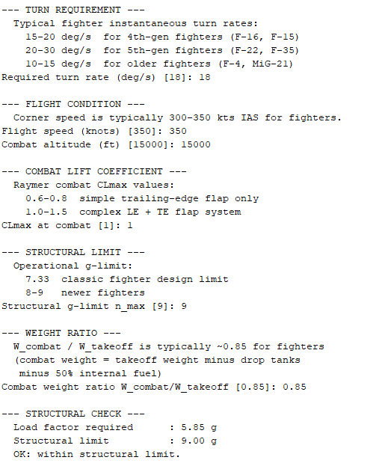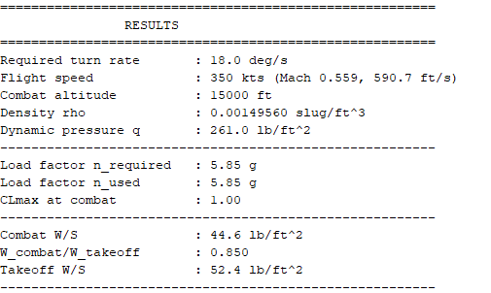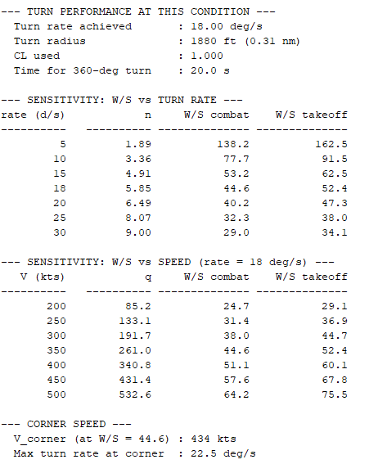

Discussion
This is a fighter-oriented constraint and should not size a transport aircraft. It produces a much lower wing loading than the transport requirements. The reported derived values are a 1,880-ft turn radius and a 20-s time for a 360° turn.

Task 9: Wing Loading from Sustained Turn
Method. Sustained-turn performance is assessed by comparing available T/W with the minimum required for the requested load factor and by solving the wing-loading relation.
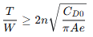
At Mach 0.90 and 30,000 ft, the study uses AR = 3.5, C_{D0} = 0.018, e = 0.65, combat T/W = 0.70, and required load factor n = 4.5. The minimum T/W is reported as 0.4517, so the condition is feasible.
Method/result | Combat W/S | Takeoff-equivalent W/S
Best-L/D condition (Eq. 5.22) | 28.4 lb/ft² | 33.4 lb/ft²
Higher root, available-thrust equation (Eq. 5.25) | 77.6 lb/ft² | 91.3 lb/ft²
Maximum sustained load factor | 6.97 g | —

Output:
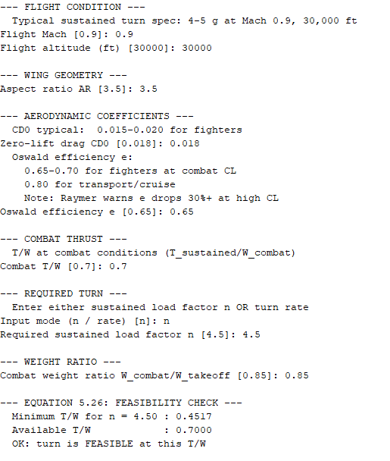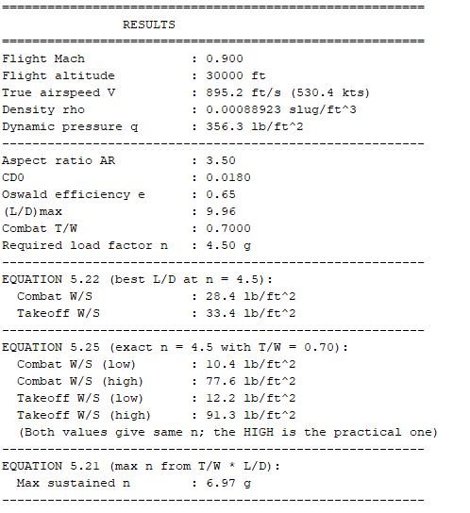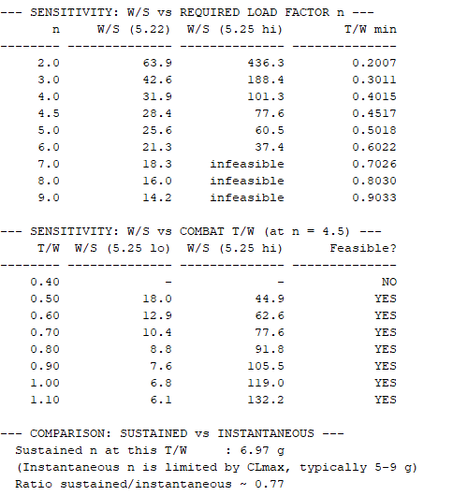

Discussion
The higher root represents the larger wing loading that can meet the specified turn requirement with the assumed available thrust. This constraint applies to fighter-type aircraft, not the transport configuration.

Task 10: Wing Loading from Climb and Glide
The FAR 25 second-segment, two-engine-out climb requirement is represented by a 2.4% climb gradient. The high-root wing-loading solution is calculated using the available climb T/W, drag polar, and dynamic pressure.
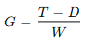
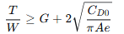
The stated inputs are 15,000 ft, 250 kt, AR = 8.68, C_{D0} = 0.020, e = 0.75, climb T/W = 0.25, and G = 0.024. The report’s sensitivity output gives W/S = 66.8 lb/ft² for the 2.4% gradient.

Output:
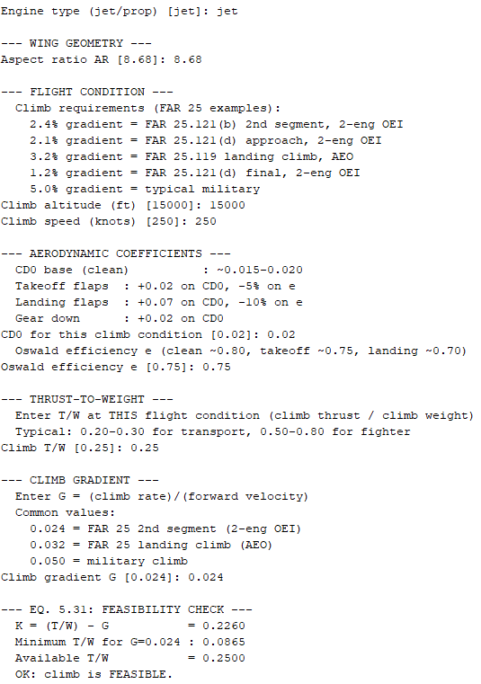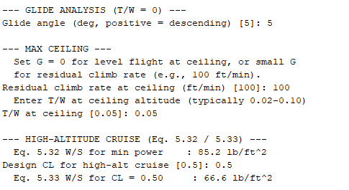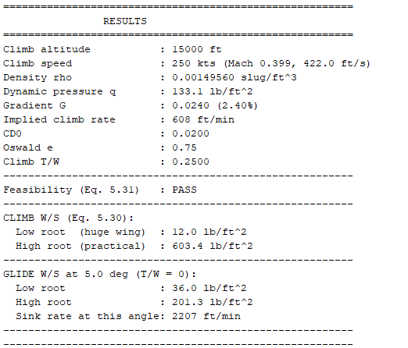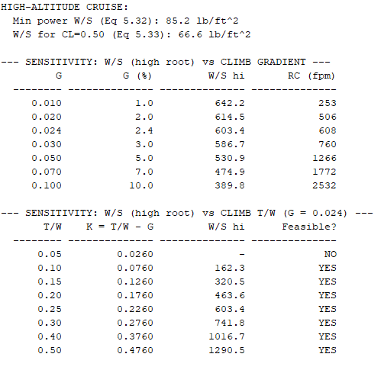

Discussion
The result indicates that climb can be more restrictive than landing when the assumed climb T/W is 0.25. However, the original report also contains a conflicting hand calculation of 117.6 lb/ft². The MATLAB implementation and inputs should be checked to resolve this before final sizing. The glide case is reported as non-controlling.

Task 11: Convert Constraints to Takeoff Conditions
Mission-condition wing-loading values are converted to takeoff weight using the mission weight fraction.
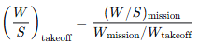
Constraint | Mission W/S (lb/ft²) | Weight fraction | Takeoff W/S (lb/ft²)
Stall | 107.5 | 1.000 | 107.5
Takeoff balanced field length | 166.3 | 1.000 | 166.3
Landing | 90.6 | 0.850 | 106.6
Climb, 2.4% OEI | 66.8 | 0.985 | 67.8
Cruise optimum | 190.8 | 0.956 | 199.6
Loiter optimum, as reported | 135.7 | 0.850 | 159.6
Instantaneous turn | 44.6 | 0.850 | 52.5
Sustained turn, best-L/D | 28.4 | 0.850 | 33.4
Sustained turn, higher root | 77.6 | 0.850 | 91.3

Output:
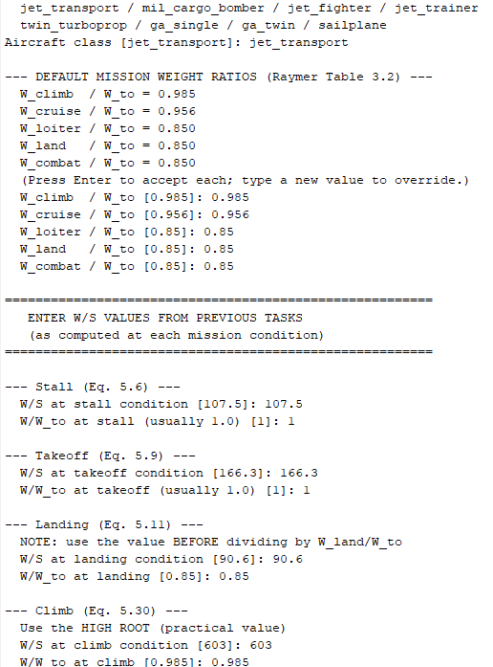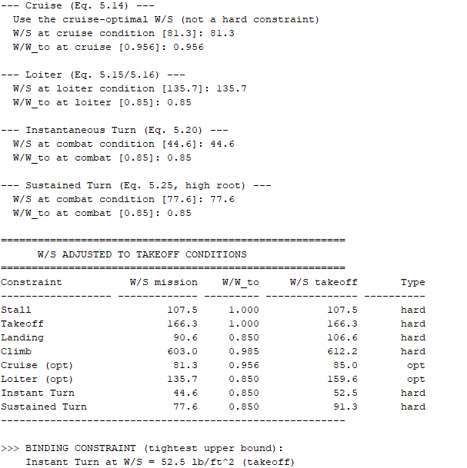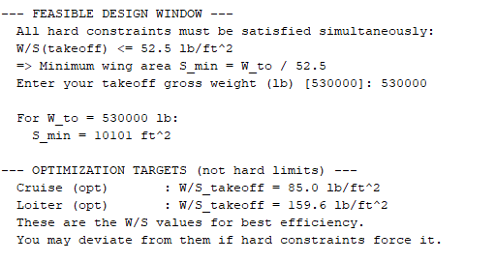

Discussion
The source report gives different binding constraints depending on the configuration and assumed climb thrust. Including fighter turn constraints, instantaneous turn is the lowest value at about 52.5 lb/ft². Excluding turn constraints, the reported climb limit is about 67.8 lb/ft² when climb T/W is 0.25. If climb thrust is increased, the report states that landing becomes controlling at 106.6 lb/ft². These cases should be kept separate rather than presented as one definitive design point.

Conclusion
The analysis estimates a takeoff T/W of 0.279 from cruise matching and compares wing-loading limits from stall, takeoff, landing, cruise, loiter, turning, and climb requirements. The field-length estimates are below the 8,000-ft runway length, although the FAR 25 takeoff estimate has limited margin. Landing gives a reported takeoff-equivalent limit of 106.6 lb/ft², while the climb result may be more restrictive under the stated T/W assumption. The final wing-sizing decision therefore depends on resolving the climb calculation and the loiter discrepancy, then confirming all constraints with a consistent MATLAB run. These are conceptual estimates and should not be treated as certification evidence.

References
Raymer, D. P. Aircraft Design: A Conceptual Approach, 6th ed. AIAA, 2018, Chapters 3 and 5.
Roskam, J. Airplane Design, Vol. I: Preliminary Sizing of Airplanes. DARcorporation, 1985.
Federal Aviation Administration. FAR Part 25: Airworthiness Standards, Transport Category Airplanes.
U.S. Department of Defense. MIL-C-5011A: Flight Performance of Aircraft.
Boeing Commercial Airplanes. 777-200/300 Airplane Characteristics for Airport Planning, D6-58329.
Shevell, R. S. Fundamentals of Flight, 2nd ed. Prentice Hall, 1989.

Appendix A: MATLAB Files
File | Purpose
thrust_to_weight.m | Statistical, cruise-matching, and climb T/W estimates
check_far_mil_compliance.m | FAR 25 and MIL field-length checks
wing_loading_stall.m | Stall-speed constraint
wing_loading_takeoff.m | Takeoff balanced-field-length constraint
wing_loading_landing.m | Landing-distance constraint
wing_loading_cruise.m | Maximum-range cruise condition
wing_loading_loiter.m | Maximum-endurance loiter condition
wing_loading_instant_turn.m | Instantaneous-turn constraint
wing_loading_sustained_turn.m | Sustained-turn constraint
wing_loading_climb_glide.m | Climb-gradient and glide analysis
adjust_WS_to_takeoff.m | Mission-to-takeoff conversion and constraint comparison

Note: The provided source was plain text and did not contain embedded MATLAB figures. Figure locations are marked in the report for the corresponding output plots to be inserted. The loiter and climb discrepancies are explicitly flagged rather than silently reconciled.

